**Project Design Phase-II**

**Data Flow Diagram & User Stories**

|  |  |
| --- | --- |
| Date | 27 June 2025 |
| Team ID | LTVIP2025TMID59561 |
| Project Name | HealthAI: Intelligent Healthcare Assistant Using IBM Granite |
| Maximum Marks | 4 Marks |

**Data Flow Diagrams:**

A Data Flow Diagram (DFD) is a traditional visual representation of the information flows within a system. A neat and clear DFD can depict the right amount of the system requirement graphically. It shows how data enters and leaves the system, what changes the information, and where data is stored.

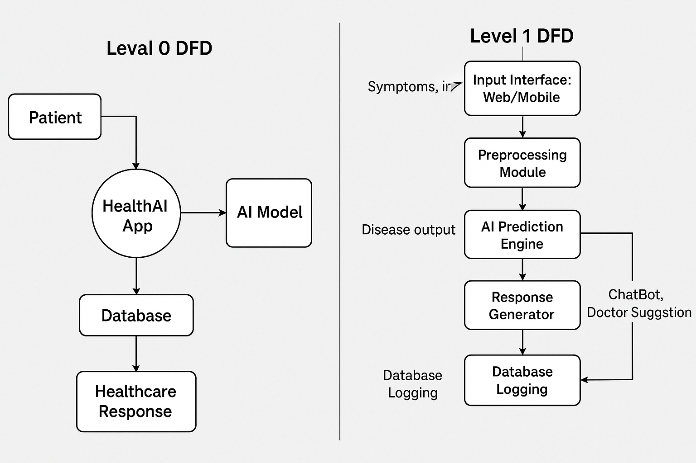

**User Stories**

|  |  |  |  |  |  |  |
| --- | --- | --- | --- | --- | --- | --- |
| **User Type** | **Functional Requirement (Epic)** | **User Story Number** | **User Story / Task** | **Acceptance Criteria** | **Priority** | **Release** |
| Customer (Mobile user) | Registration | USN-1 | As a user, I can register for the application by entering my email, password, and confirming my password. | I can access my account / dashboard | High | Sprint-1 |
| Customer (Mobile user) | Registration | USN-2 | As a user, I will receive confirmation email once I have registered for the application | I can receive confirmation email & click confirm | High | Sprint-1 |
| Customer (Mobile user) | Registration | USN-3 | As a user, I can register for the application through Facebook | I can register & access the dashboard with Facebook Login | Low | Sprint-2 |
| Customer (Mobile user) | Registration | USN-4 | As a user, I can register for the application through Gmail | I can register using Gmail and access my dashboard | Medium | Sprint-1 |
| Customer (Mobile user) | Login | USN-5 | As a user, I can log into the application by entering email & password | Successful login redirects to the dashboard | High | Sprint-1 |
| Customer (Mobile user) | Disease Prediction | USN-6 | As a user, I can input my symptoms and get disease prediction | I get a probable disease prediction based on my input | High | Sprint-2 |